Dojo Etiquette & Policies

General
- Be on time. Late arrivals disrupt class and cause the late student to miss important warm up exercises that could lead to injury.
- If you need to leave before class is over, please let a sensei know. Please do so discretely so as not to disrupt class.
- Judokas and guests must be respectful at all times to other students and instructors.
- Upon entering the dojo, a positive and open attitude is expected by all.
- Be ready and properly attired for class.
- Notify instructor immediately of any injuries.

During Practice
- Bow before stepping on/off the mat, at the beginning of practice and to sensei, before/after uchikomi with partner, and at the end of practice.
- Wear your gi for the entire practice. At the beginning and the end of uchikomi/nage komi/randori and at the end of practice please make sure your gi is properly arranged.
- Opportunities for water will be given throughout practice. However, if you need water to help with dizziness, nausea and/or fatigue before the next break, please do so quietly and bow off the mat.
- The proper way to sit and pay attention is in the traditional SEIZA (kneeling) position.
- If your legs/knees become uncomfortable, you may sit cross-legged. This shows that you are paying attention and ready to learn.

Hygiene
- Long hair must be tied back-in a braid, bun, or ponytail
- Nails-both hands and feet-must be trimmed
- No perfume, cologne, or other strong smells
- All jewelry must be removed and unremovable piercings must be taped
- Please tape cuts, etc. and clean blood off mat with disinfectant immediately
- Shoes and sandals must be worn to the restrooms
- Your gi must be clean and in good condition

SEIZA ( with an exercpt from Shiro Kuma’s blog)
The seiza 正座 or 正坐 (kneeling with the tops of the feet flat over the floor, and sitting on the soles) or the seiza 静座 or 静坐 (sitting calmly and quietly in order to meditate) are the same but differ in their meaning.

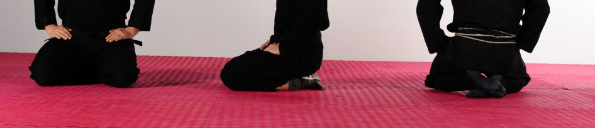

Please see the following article if you would like more information:
https://kumafr.wordpress.com/2010/08/11/seiza-or-seiza/
